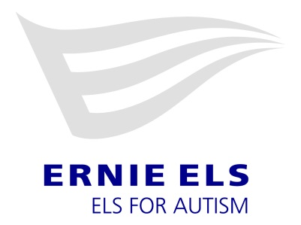
Events Coordinator
Job Description
The Events Coordinator is responsible for the coordination of all fundraising events hosted by the Foundation and to fulfill or exceed their fundraising goals. The Events Coordinator develops sponsorship/trade/business arrangements and relationships with businesses, individuals and organizations interested in supporting the Foundation’s events and activities. This position is responsible for the logistics, communications, and operations of each event. The Coordinator will work with the Events Manager to finalize event decisions, with the marketing team to publicize events, and on other projects with the Events Manager and Managing Director in attracting funding for the Foundation.
This position will report to the Events Manager on a regular basis and will have office hours of Monday-Friday, 9 AM – 5 PM plus weekends and evenings where required. The below list of specific event tasks are examples of the obligations that this position will be asked to support.
Duties include, but are not limited to, the following:
- Secure location and date for each fundraiser in a timely manner.
- Review and sign contracts with event site venues.
- Assist with creating the 2020 Golf Challenge schedule and review all contracts and BEOS with course venues.
- Vet, contract, and manage relationships with vendors.
- Create and manage budgets.
- Solicit sponsors to underwrite costs, increase the revenue of the event, and/or increase the value of the event and experience to attendees.
- Coordinate staff and volunteer responsibilities and assignments.
- Create an overall theme, décor plan, and event flow for each fundraiser.
- Supply design briefs to the marketing team for invitations, promotional materials, programs, signage, and any additional event-based materials.
- For events involving a ticket donation or auction, secure items and organize and create all materials for ticket donation or auction.
- For events involving a gift bag or attendee gift, solicit and secure donations.
- Create and manage shipping schedules for any offsite events to ensure all items are received in a timely manner.
- Keep in-kind donation spreadsheets and send receipts to close out each event.
- Maintain Donor Perfect website so that all donations and sponsorships are catalogued properly.
- Input all donation checks and payments into Raisin or Donor Perfect for each fundraising event. Includes managing any refunds.
- Maintain consistent communications with sponsors, donors, and event attendees pre-event, during, post-event, and throughout the year for appointed events.
- Oversee and manage the Affiliate Event Program.
- Submit all social media posts (contracted for sponsors and event promotion/wrap-up images) to the marketing team for posting with appropriate timing.
- Communicate with event attendees leading up to event regarding all logistics required which can include transportation and accommodations.
- Travel to any offsite events required by the Foundation
- Assist with any on campus fundraising events.

Position Qualifications and Knowledge:
Education and Experience:
- Bachelor’s Degree required.
- Two plus years of event coordination experience. Marketing experience highly desirable.
- Proven success in meeting and exceeding performance goals.
Job Knowledge and Skills:
- Has a strong performance orientation and skillful strategic thinking. Establishes clear expectations and continuously measures performance.
- The ability to work through stringent deadlines with acute attention to detail is required. Maintains focus on priorities.
- Self-starter with the ability to manage time effectively.
- Demonstrates excellence in both oral and written communications. Knowledge of external communications and cultivation techniques are essential.
- A high degree of integrity in dealing with confidential donor, supported family and financial information.
- Ability to coordinate all aspects of an event or conference including - logistics, correspondence, financial reports and printed materials.
- Ability to coordinate with and lead a team of volunteers.
- Commitment to the mission of serving individuals with autism spectrum disorder.
- Proficiency in Microsoft Office and email.
- Ability to connect with others and forge strong relationships.
- Experience working in or with diverse communities.
- Knowledge of golf desirable.

